Prevent Disruptive Behavior by Using the Good Behavior Game
Ms. Jones is a young teacher in a middle school, and this is her first year teaching sixth to eighth grade students. Although most of her students can follow the rules and directions, there are always a few students who talk to each other in the classroom.
Talking is not a serious problem, but it can bother other students and interrupt Ms. Jones’s teaching. Sometimes Ms. Jones feels tired and frustrated. She often has to stop her lessons to manage those talking students, or they will talk louder and louder.
Ms. Jones has tried verbal warning and ignoring those students to decrease the frequency of talking in the classroom, but it hasn’t work too well. Recently, she used the Good Behavior Game to address the talking problem, and she found it worked very well at managing students’ talking and other disruptive behaviors in the classroom.

A short story

Disruptive behaviors
What:
According to studies, disruptive behavior is student noncompliance with teacher requests (De Martini-Scully, Bray, & Kehle, 2000). More specifically, disruptive behavior in the classroom is defined as behavior that interrupts or inhibits the teaching and learning processes. Common disruptive behaviors in the classroom setting may include talking, being out-of-seat, name calling, cursing and verbal aggression.
Although disruptive behaviors may not cause severe harm to other people or things, teachers have to spend considerable time to control the classroom. As a result, there is a decreased amount of time spent on academic instruction. In addition, many teachers don’t know how to deal with this behavior problem until after the disruptive behaviors happen.

Contents
Short story 1
Disruptive behaviors 1
Good Behavior Game 2
Now What 3
Procedures of
Good Behavior Game 3
Pros 4
Cons 5
Conclusion 5


So What:
Just as with Ms. Jones in the story, managing and preventing disruptive behavior is a topic of concern to many middle school educators. Therefore, there is an obvious need for a teacher-friendly, effective intervention to prevent disruptive behavior in the classroom. Previous studies indicated that there were several kinds of interventions for teachers to prevent the disruptive behavior. For example, De Martini-Scully et al. (2000) successfully combined precision requests with positive reinforcement, reductive techniques, and commands to prevent the disruptive behavior; another study integrated posted classroom rules with a token economy, response cost, and mystery motivators (Mottram, Bray, Kehle, Broudy, Jenson, 2002). However, those interventions all connected many different behavioral management techniques. Sometimes they were too complicated and need too much preparation time for teachers to implement during the class.
This newsletter introduces a simple and effective method to decrease students’ disruptive behavior called the “Good Behavior Game”. The effectiveness of the Good Behavior Game has been prove through “single-case research, ABAB, multiple beseline, and changing criterion design” (Tingstrom, Sterling-Truner, & Wilczynski, 2006, p. 227).
Good Behavior Game
About 30 years ago, Barrish, Saunders, and Wolf, published a study called the Good Behavior Game. The game first was applied successfully in a classroom of fourth grade students with high rates of talk-outs and out-of-seat behavior (Lannie & McCurdy, 2007). It worked well, and most graduate students in behavior analysis or special education learned it during the “heyday of behavioral psychology (p. 276)” (Embry, 2002).
The Good Behavior Game is an interdependent group contingency particularly well-suited to the classroom (Tingstrom, Sterling-Truner & Wilczynski, 2006). In a group contingency, all groups receive the same consequence in any given activity, but the behaviors and performance of all group members have to reach a particular standard, after which the group members can receive a reward (e.g., “When team’s check marks are below 6 at the end of 30 minutes, the members of the team will get additional recess time.”). In other words, although some individual students may not meet the criterion, all students are provided with the reinforcer as long as the group meets the criterion.

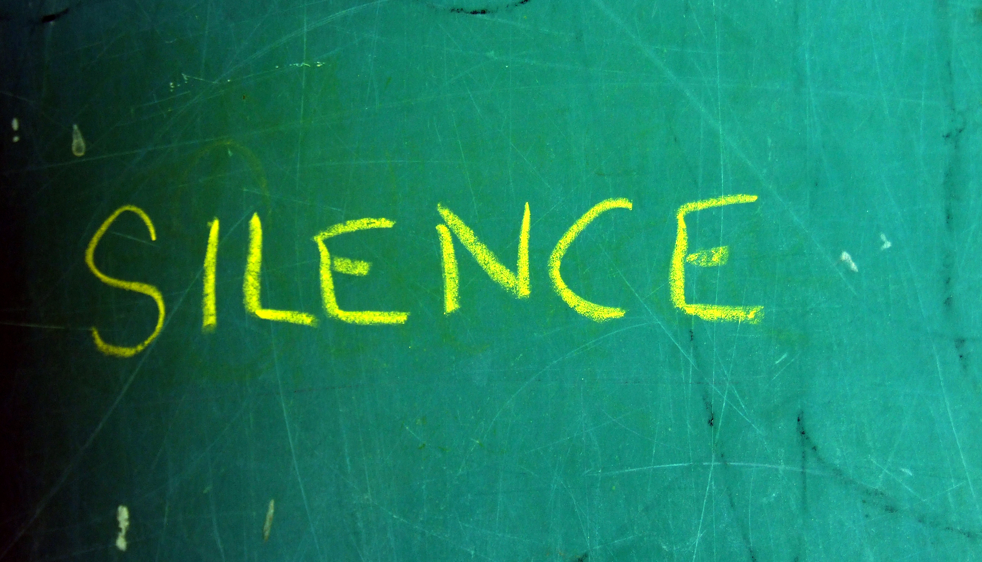
Classroom management is an important component of effective teaching (Lannie & McCurdy, 2007, p. 94)

You may want to know what kind of population is appropriate for the Good Behavior Game first. On one hand, the primary participants in Good Behavior Game studies were students in first through sixth grades. On the other hand, the Good Behavior Game has also been used successfully with preschoolers and adolescents. All student participants in those previous studies were either typical development children who were in general classes or who had a history of behavior problems. Of course, there were a few studies focused on students with disabilities and cultural variables. As a result, we know the Good Behavior Game has been used efficiently across several age levels. Therefore, the game is a good way to prevent the general disruption of 90% students.
Why is the Good Behavior Game so powerful at decreasing students’ disruptive behavior in the classroom? This is because disruptive, disagreeable behaviors by students might happen “due to peers and others reinforced them in school settings (p. 279)”. Probably, the smiles, giggles, laughs, and even pointed taunting from other students would reinforce the behaviors that teachers found so difficult to handle and harmful to learning process (Embry, 2002). Therefore, a group-based reward for inhibiting negative behavior like the Good Behavior Game could deal with the disruptive behavior effectively.
Now What:
We have the basic concepts about the disruptive behavior and Good Behavior Game. Now we have to know how to connect them together to prevent the students’ disruptive behaviors in the classrooms.
Next, let’s breakdown the procedures for teachers to execute the Good Behavior Game. Harris & Sherman (as cited in Tingstrom et al., 2006) analyzed the components of Good Behavior Game, and suggested only three essential features of the Good Behavior Game: (1) dividing the class into teams, (2) setting criteria for winning, and (3) reinforcement for the winning team. The following are the detail steps to implement the Good Behavior Game (Embry, 2002):
- Teachers announce the rules of the game to students such as “no tattling” and “no out-of-seat”. Theses specific rules make the classroom or nonacademic setting a good place to learn, more enjoyable, and pleasant. All of the rules are labeled as “the good things we all want.”
- Teachers elicit and combine students’ descriptions of behaviors that would interfere with desirable outcomes and label those negative behaviors as “fouls.”
Good Behavior
Game is a
behavioral
vaccine
(Embry, 2002)



3. Teachers provide examples of both (the good things and fouls) which are presented physically and in words for the children to form a generalized concept.
4. Teachers explain that the game is played at intervals. The duration of the game should base on the length of academic period.
5. Teachers divide the group into teams and explain that a team may win the Game by having the fewest fouls (or fouls is below a criterion, so enabling multiple winners). The prize (reinforcer) could occur naturally in the school setting. The common planned reinforcers include free time, additional recess time, or additional activity time. The activity reinforce could be working special art and science projects, being teachers’ helper and so on. Other creative reinforecers include leaving school 10 minutes early or a special visit from school principle.
6. A scoreboard should be highly visible in the classroom, like the scoreboard of baseball or football with fouls much smaller than wins.
Below is a short summary of the pros and cons of the Good Behavior Game for every educator. This will help you use the Good Behavior Game (Tingstrom, 2006):
Pros
- The events and activities are efficient resources and difficult to purchase, steal, or share.
- The Good Behavior Game utilizes the group solidarity and cooperation within teams, so it could lead positive side effects such as increasing prosocial and cooperative behaviors among group members.
- Students can win the game in a variety ways; thus, students may be motivated to behave appropriately according to the rules. Even if they have met the criterion, they still have motivation to behave appropriately in order to surpass the competing teams to gain the rewards.
- Group-oriented procedures may alleviate some teachers’ concern that a particular student will be singled out and treated differently.
- The game is a great deal of flexibility and can be designed to be as simple or as complex as desired.

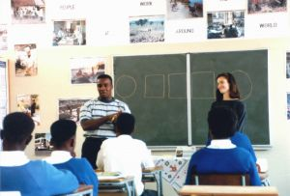
- The game may not require rigorous compliance on the part of the teachers to be effective.
Cons
- Peer influence can be the greatest potentially disadvantage: O’Leary and Drabman (1971) found peer influence can produce undue pressure verging on harassment toward the individual who does not exhibit the requisite behaviors. Besides, some students may think the game is not fair when others cause the loss of rewards. More seriously, students who already have difficulty with self-control may deepen their frustration or behave aggression toward the offending students. To prevent these problems, teachers should emphasize appropriate reactions to offending students and warn to students that negative reaction won’t be tolerated before the beginning of the game. Studies have shown this to be an effective safeguard.
- Similar to all interdependent group contingencies, students may still not comply with the rules of good behavior, if the reinforcers are not attractive enough or are not what they want. An optimal alternative for teachers to solve the problem may be to use a combination of individual and group-oriented contingencies.
Conclusion
Although different studies have suggested different interventions to prevent students’ disruptive behavior in classrooms, the positive effects of the Good Behavior Game have been recognized by several sources such as Colorado Violence Prevention Blueprints Project and Substance Abuse and Mental Health Administration (Embry, 2002). Besides, many researchers identified the Good Behavior Game as one of the few universal, simple strategies useful for dealing with disruptive behaviors.
A common problem implementing an intervention in the classroom is the willing and acceptance of the teachers. According to Tingstrom (1994), the Good Behavior Game was found to be acceptable as individually based interventions by teachers. We encourage you to try this powerful but simple strategy on the disruptive behaviors in your classroom and school.



Want to learn more about preventing the disruptive behaviors with the Good Behavior Game. Check these resources.
De Martini-Scully, D., Bray, M. A., & Kehle, T. J. (2000). A packaged intervention to reduce disruptive behaviors in general education students. Psychology in the Schools, 37(2), 149-156.
How can you learn more?
A combination multiple baseline/ reversal design assessed the effectiveness of a packaged intervention included a contingency contract, antecedent strategies, positive reinforcement, and the reductive technique of response cost to reduce disruptive behaviors in two 8 year-old students.
Embry, D. D. (2002). The Good Behavior Game: A best practice candidate as a universal behavioral vaccine. Clinical Child and Family Psychology Review, 5(4), 273-297.
The author introduced the definition of behavioral vaccines, and considered the Good Behavior Game one of them. In addition, the article reviewed the procedures of the game and provided some practical issues when implementing the game.
Lannie, A. L., & McCurdy, B. L. (2007). Preventing disruptive behavior in the urban classroom: Effects of the Good Behavior Game on student and teacher behavior. Education and Treatment of Children, 30(1), 85-98.
The study examined the effects of the Good Behavior Game on student behaviors and teacher’s response statements.
Mottram, L. M., Bray, M. A., Kehle, T. J., Broudy, M., & Jenson, W. R. (2002). A classroom-based intervention to reduce disruptive behaviors. Journal of Applied School Psychology, 19(1), 65-74.
This article investigated the effectiveness of an intervention that combined posted classroom rules, token economy, response cost, and mystery motivators in reducing the disruptive behaviors in the classrooms.
Tingstrom, D.H., Sterling-Truner, H.E., & Wilczynski, S. M. (2006). The Good Behavior Game: 1969-2002. Behavior Modification, 30(2), 225-253.
This literature review is a good resource to provide us a clear understanding of the Good Behavior Game.
Tingstrom, D.H. (1994). The Good Behavior Game: An investigation of teachers’ acceptance. Psychology in the Schools, 31, 57-65.
The study investigated teachers’ satisfaction with and acceptance of the Good Behavior Game.

These great websites can help you learn more.
Dealing with disruptive behavior in the classroom. Illinois State University, Center for Teaching Learning & Technology. Retrieved February 25, 2008, from http://www.teachtech.ilstu.edu/additional/tips/disBehav.php
This site provides some simple strategies for teachers dealing with the students’ disruptive behaviors.
Good Behavior Game. Blueprint for violence prevention, Blueprints Promising Program. Retrieved from March 10, 2008, from http://www.colorado.edu/cspv/blueprints/promising/programs/BPP06.html
The website is a short summary of Good Behavior Game. In addition, it provideds some useful links.
Good Behavior Game. Intervention center. Retrieved from March 10, 2008, from http://www.interventioncentral.org/htmdocs/interventions/classroom/gbg.php
Besides the steps to use the Good Behavior Game, the website provideds some suggestions and common Q & A when utilize the Good Behavior Game.

Variation of the Good Behavior Game. TeacherVision, Technique Methods and Strategies. Retrieved from March 10, 2008, from http://www.teachervision.fen.com/teaching-methods/classroom-management/9167.html

This website provides a case and then teaches educators how to use the Good Behavior Game to intervene on the students’ disruptive behavior.

